 Sprint 2

Jira will be updated as we go along and all information/data shall be tracked.

This page shall show some insight into sprint 2 and record how it went.

**Monday 2nd March 2020**

All user stories taken from the product Backlog to create the sprint plan.

Originally six user stories were broken up into tasks for Sprint 2. But with one

Task not being fully completed in sprint 1, it was moved into sprint 2

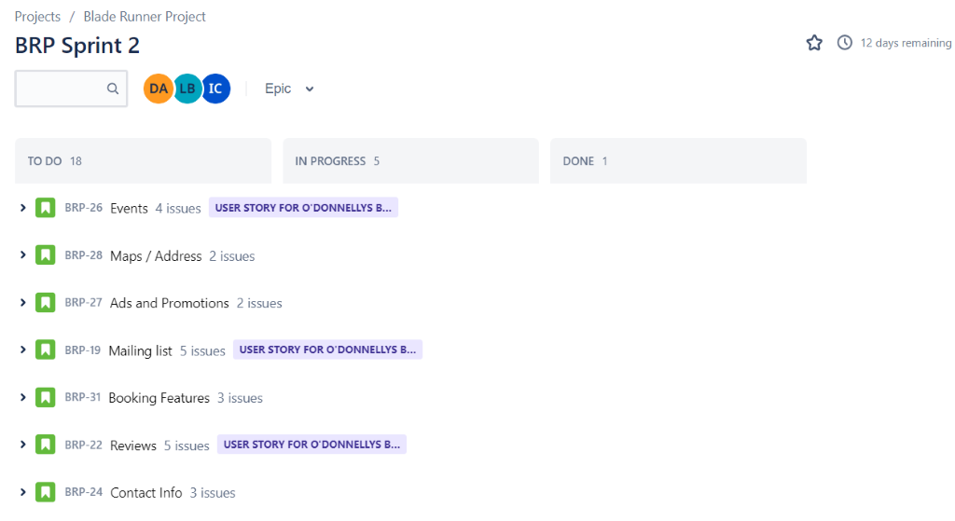

Tasks have initially been picked by members to work on.

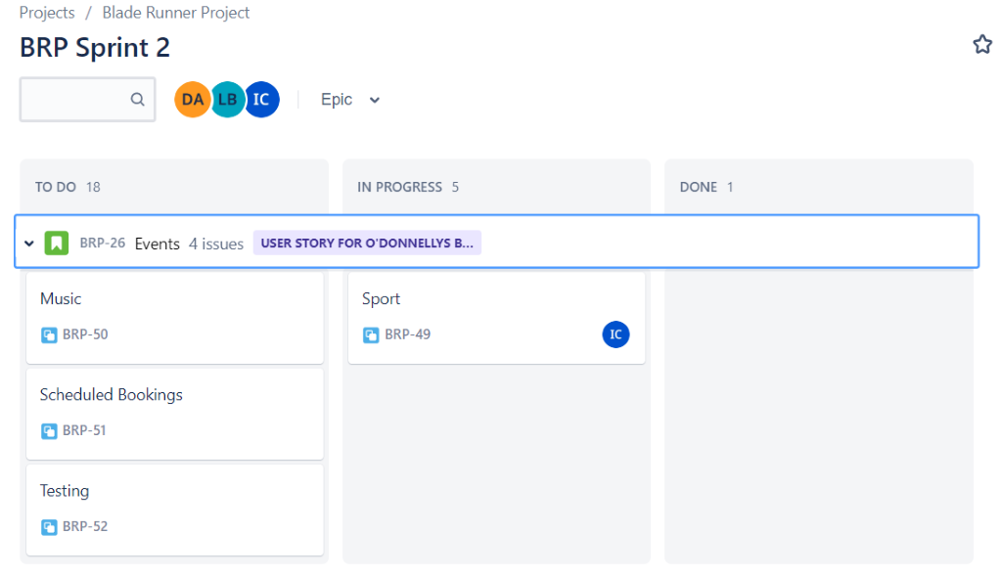

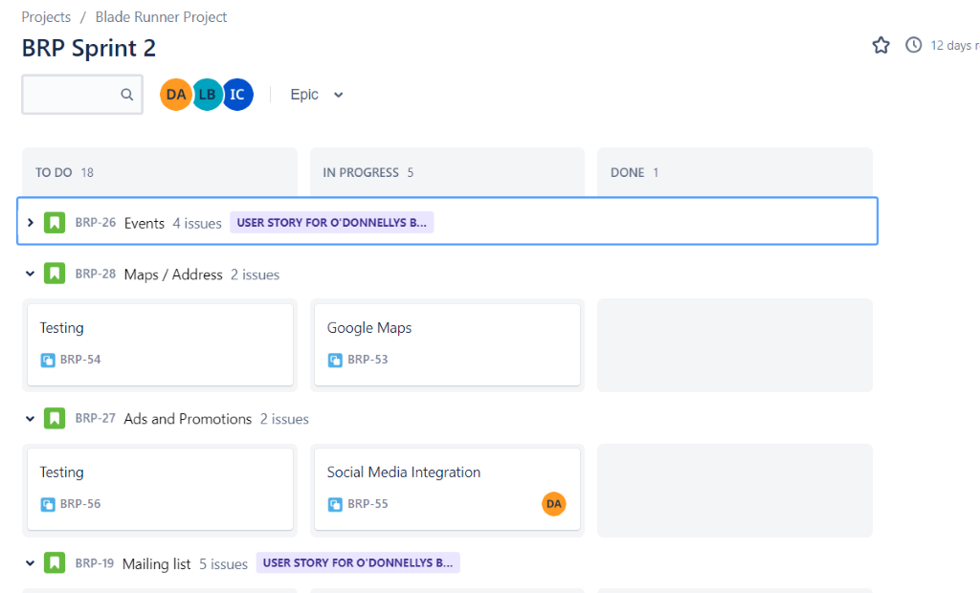

====================================================================

**Burndown chart Sprint 2**

Burndown chart for sprint 2, no data to show at this stage as it's all in the planning.

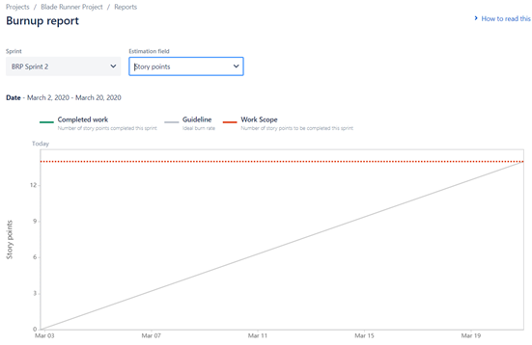

**Wednesday 5th March 2020**

Tasks have been assigned to members. Keeping Jira up to date unlike sprint 1.

 Keeping data accurate.

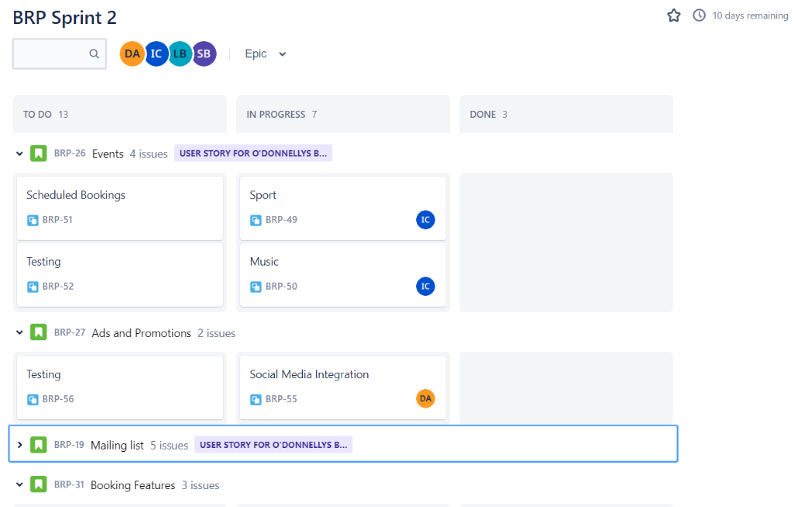

David working on social media integration and mailing list form.

Ion working on GDPR.

Luke continuing with dealing with testing.

====================================================================

**Burndown chart Sprint 2**

Three days into sprint. Burndown chart already recording movement within the

Sprint, through progression of tasks.

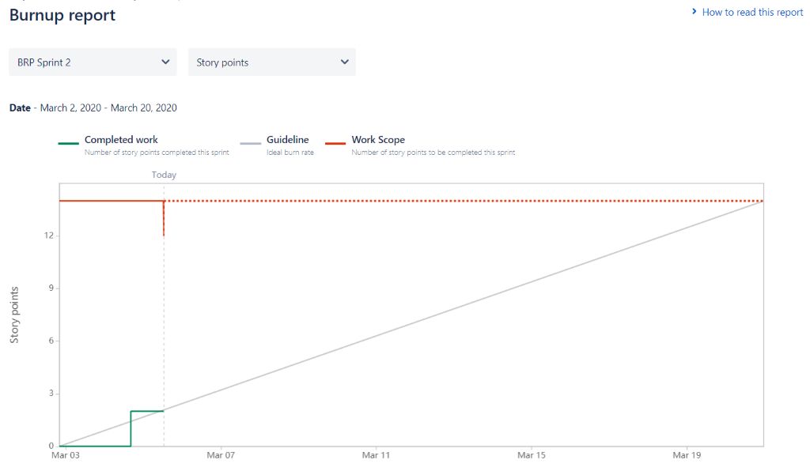

As seen in the image provided. A Spike user story was to be added to the Sprint.

But to make room for the task, we had to take away the review user story to keep

Our velocity.

Review task was moved into the backlog for future releases.

